**Artificial Intelligence and Data Science Department.  
Web Computing / Even Sem 2021-22 / Experiment 1.  
___________________________________________________________________**

**YASH SARANG .  
47 / D11AD.  
EXPERIMENT - 1.  
___________________________________________________________________**

**Aim -**

To create a html webpage containing html elements like head, body (along with some formatting), paragraph, also include an image, a video, hyperlink, and a table of your choice.

**Theory -**

**HTML : HyperText Markup Language (or HTML)**

With the aid of a markup language, it is used to design web pages.

The acronym HTML stands for Hypertext Markup Language.

The link between web pages is defined by hypertext.

The text document inside the tag that specifies the structure of web pages is defined using a markup language.

This language is used to annotate material so that a computer can comprehend it and modify the content as necessary.

Most markup languages, like HTML, can be read by people.

The language employs tags to specify what text processing is required.

**1. Head :** The <head> element is a container for metadata and is placed between the <html> tag and the <body> tag.

**2. Title :** The <title> tag defines the title of the document.

The title must be text-only, and it is shown in the browser's title bar or in the page's tab.

**3. Body :** The <body> tag defines the document's body. The <body> element contains all the contents of an HTML document, such as headings, paragraphs, images, hyperlinks, tables, lists, etc.

**4. Headings :** HTML headings are defined with the <h1> to <h6> tags.

<h1> defines the most important heading. <h6> defines the least important heading. <h1> headings should be used for main headings, followed by <h2> headings, then the less

important <h3>, and so on.

**5. Paragraph :** The HTML <p> element defines a paragraph. A paragraph always starts on a new line, and browsers automatically add some white space (a margin) before and after a paragraph.

**6. Images :** The HTML <img> tag is used to embed an image in a web page.

Images are not technically inserted into a web page; images are linked to web pages. The <img> tag creates a holding space for the referenced image. The <img> tag is empty, it contains attributes only, and does not have a closing tag.

**7. Video :** The HTML <video> element is used to show a video on a web page.

**8. Table :** HTML <table> tag allows web developers to arrange data into rows and columns. Table headers can be added using the <th> tag. Each table cell is defined by a <td> and a </td> tag. Everything between <td> and </td> are the content of the table cell. Each table row starts with a <tr> and ends with a </tr> tag.

**9. HyperLink :** The HTML <a> tag defines a hyperlink. You can click on a link and jump to another document. The most important attribute of the <a> element is the <href> attribute, which indicates the link's destination.

**10. Lists :** HTML lists allow to group a set of related items in lists. An unordered list starts with the <ul> tag. Each list item starts with the <li> tag. An ordered list starts with the <ol> tag. Each list item starts with the <li> tag.

**Conclusion:**

We have successfully learned to create an HTML page with HTML elements.

**Code Snippets :-**

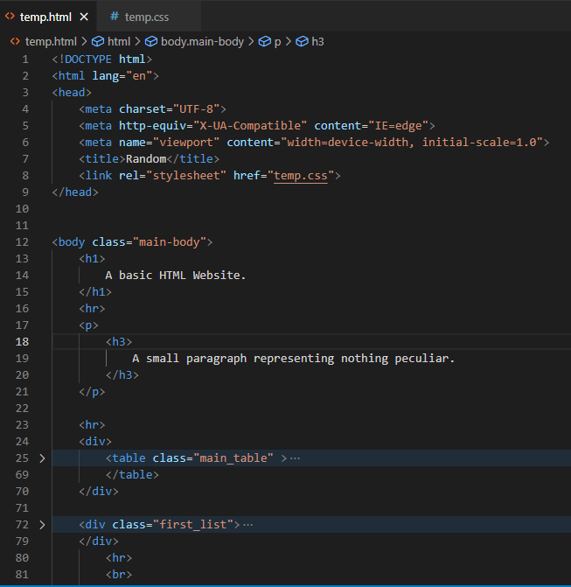

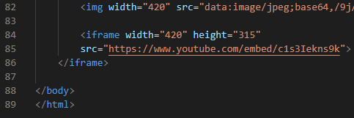

**Output:**

